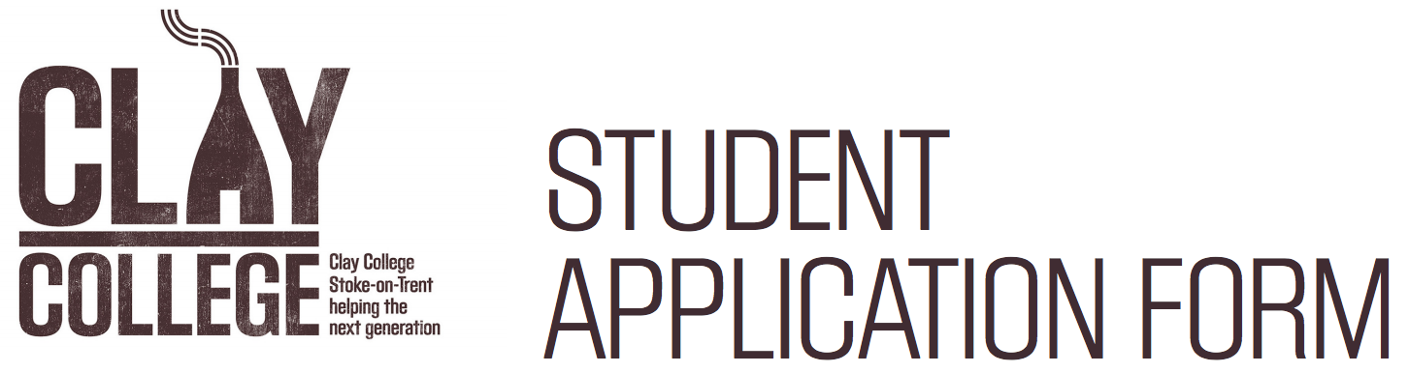

This form is an editable in word, please type in the boxes to complete. Alternatively, you can print, complete and submit by post.
PERSONAL DETAILS
SURNAME NAME(S) (as shown on passport):
FIRST NAME(S) (as shown on passport):
DATE OF BIRTH (DD/MM/YYYY):
PASSPORT NUMBER: |  |  | NATIONALITY ON PASSPORT
PERMANENT HOME ADDRESS:

EMAIL ADDRESS:
TELEPHONE NUMBER (including codes):
NAME OF EMERGENCY CONTACT:
PHONE NUMBER EMERGENCY CONTACT:

PERSONAL STATEMENT
Why do you want to come to Clay College Stoke?
How will this course help you?

What do you hope to achieve by attending Clay College Stoke? What are your long-term ambitions?

What qualities would you bring to Clay College Stoke?

Describe your strengths and weaknesses:

Tell us about a potter, historical or contemporary, whom you admire and describe how their work inspires your work:

QUALIFICATIONS AND EXPERIENCE
Tell us about your Arts and/or Ceramics studies to date:
What is your current level of skill with ceramics?
SECONDARY AND FURTHER EDUCATION. Specify GCSE, CSE, ‘O’, ‘A’ level or equivalent (if applicable)
INSTITUTION | COURSE/LEVEL | MARK/GRADE | START DATE | END DATE
HIGHER EDUCATION/PROFESSIONAL QUALIFICATIONS OR EQUIVALENT COURSES (if applicable)
INSTITUTION | COURSE/LEVEL | MARK/GRADE | START DATE | END DATE
EMPLOYMENT HISTORY
NAME OF EMPLOYER | JOB TITLE AND BRIEF OUTLINE OF THE JOB |  | START DATE | END DATE

PORTFOLIO
Please supply a portfolio of 6 images of recent work (preferably ceramics but images of all work are welcome).
In the table below, please tell us how each piece was made.
IMAGE ONE
IMAGE TWO
IMAGE THREE
IMAGE FOUR
IMAGE FIVE
IMAGE SIX

FEES
Before you join the course at Clay College Stoke you must ensure that you have adequate financial provision to cover tuition and living expenses.
Who will pay your tuition fees?
SELF-FUNDED |  | FAMILY |  | SCHOLARSHIP/SPONSORSHIP* |  |  | OTHER**
*If scholarship/sponsorship, please state organisation/person and contact address: |  |  |  |  | **If other please supply details:
Limited bursaries will be available and can be applied for separately. Applicants should be prepared to provide proof of hardship in the case of bursary applications.

REQUIRED DOCUMENTS
Please include the following with this application form. Please tick the box to confirm inclusion:
A COPY OF YOUR PASSPORT/EU ID CARD
A REFERENCE OR LETTER OF RECOMMENDATION ON HEADED PAPER FROM YOUR EDUCATIONAL INSTITUTION OR CURRENT/PAST EMPLOYER
YOUR PORTFOLIO OF 6 IMAGES. Please ensure images are no more than 1MB each and that the file/image name corresponds with the number on the table above. Please send the best photos that you can, taken against a clean, uncluttered background.
THE CLAY COLLEGE STOKE EQUAL OPPORTUNITIES FORM

DECLARATION AND SIGNATURE
I confirm that the information given in this form is complete and accurate. I understand that the application or any subsequent place at the College may be withdrawn by Clay College Stoke if in the future the information provided proves to be inaccurate either intentionally or unintentionally.

By signing this form:
- I give my permission to Clay College Stoke to verify the information contained in this application with the institution, relevant awarding body or referees provided.
- I give my permission to Clay College Stoke to store and process my data in line with the privacy notice.

SIGNATURE: | DATE:
If returning digitally, typing your email address into the signature field will be accepted as your signature

Please return this completed form by:
EMAIL application@claycollegestoke.co.uk
POST Clay College, Middleport Pottery, Port Street, Stoke-on-Trent, ST6 3PE

